Report on Comments Compliments and Complaints for the period 1 April 2006 to 30 September 2006

Statistical Report

Table 1: Stages of the Complaints Process

STAGE | DEFINITION
STAGE 1 (Registration) | The local manager considers if the complaint falls within the CAFCASS complaints procedure. Any complaint by a child or young person is considered under the complaints procedure.
STAGE 2 (Problem Solving) | The local manager works with the complainant and the CAFCASS employee or contractor to achieve resolution.
STAGE 3 (Investigation) | The complaints investigator produces a written report for the Regional Director.
STAGE 4  (Review) | Review is to a Board Member and Regional Director independent of the Region. This is not a re-hearing of the complaint but an assessment as to how the complaints process has been applied.

Where the complainant completes the process and still remains dissatisfied, he or she is able, through a sponsoring MP, to raise the matter with the Parliamentary and Health Service Ombudsman.

This report analyses information on complaints that have been entered onto the new Response and Feedback Log, which is specifically designed to record and track information at all levels. It focuses on:

- The overall numbers of complaints received by each region;
- The stage they were, or are currently being considered;
- The nature and outcomes of the complaints;
- The case status, ethnicity and gender of those who made the complaints.
- Enquiries made of CAFCASS by Members of Parliament or by the Parliamentary and Health Service Ombudsman and directly.

Complaints received in the period

- A total of 296 complaints were received between 1st April and 30th September 2006.

Table 2: Number of Complaints received against case referrals

Region | Total Number of Case Referrals | Total Complaints Received | Percentage
East | 1251 | 16 | 1.3%
East Midlands | 1605 | 24 | 1.5%
Greater London | 2388 | 32 | 1.3%
North East | 1184 | 12 | 1.0%
North West | 2893 | 44 | 1.5%
South East | 1383 | 28 | 2.0%
South West | 1545 | 39 | 2.5%
Southern | 1156 | 35 | 3.0%
West Midlands | 2062 | 28 | 1.4%
Yorks & Humbs. | 2813 | 38 | 1.4%
Total | 18280 | 296 | 1.6%

Table 2 shows the total number of complaints received in each region set against the total number of cases requested in the period for comparison.

The total number of complaints received has increased to 296 from 250 for the same period last year. This is reflected in the rise in complaints recorded as received but not registered, and is at least partly accounted for by the improved recording by managers of complaints that do not then progress further. The corresponding rise in the numbers of comments received indicates that many of these are then being dealt with as comments rather than registered complaints (see table 10).

Number of Complaints registered against case referrals

Region | Total Number of Case Referrals | Total Complaints Registered | Percentage
East | 1251 | 3 | 0.2%
East Midlands | 1605 | 3 | 0.2%
Greater London | 2388 | 9 | 0.4%
North East | 1184 | 4 | 0.3%
North West | 2893 | 23 | 0.8%
South East | 1383 | 15 | 1.1%
South West | 1545 | 12 | 0.8%
Southern | 1156 | 11 | 1.0%
West Midlands | 2062 | 8 | 0.4%
Yorks & Humbs. | 2813 | 27 | 1.0%
Total | 18280 | 115 | 0.6%

Table 3 below shows the type of complaint (eg officer bias, report content, etc) as recorded on the Response Feedback Log (RFL). Each complaint entered onto the RFL must have a ‘lead issue’ selected from a list of 14. A complaint can however have more than one category. The information given demonstrates the recorded emphasis towards complaints being about professional conduct (80), content of report (49), and officer bias (47).

Table 3 – Type of Complaint

Lead Issue | Number of Complaints | % of Total
Child Protection Issues | 2 | 0.7%
Communication | 14 | 4.7%
Complaint from Other Orgs | 1 | 0.3%
Complaint to be Clarified | 7 | 2.4%
Content of Report | 49 | 16.6%
Failure to Investigate | 16 | 5.4%
Gender | 1 | 0.3%
National Standards Not Followed | 9 | 3.0%
Not Acting in Child's Best Interest | 21 | 7.1%
Not Detailed (by complainant) | 5 | 1.7%
Officer Bias | 47 | 15.9%
Organisation Related | 1 | 0.3%
Other Diversity Issues | 1 | 0.3%
Process Issues | 37 | 12.5%
Professional Conduct | 80 | 27.1%
Racism | 4 | 1.4%
Training Issue | 1 | 0.3%
Total: | 296 | 100.0%

From this information we can see that there has been a significant reduction in complaints where the primary issue was not acting in the best interests of the child (44 at the same time last year) and a rise in complaints where the primary issue was about professional conduct (40 at the same time last year).

Table 4 – Type of complaint per region

 | Officer Bias | Report Content | Race | Gender | Other Diversity Issues | Professional Conduct | National Standards not followed | Process Issue | Complaint from other agency | Child Protection | Not acting in the interests of the child | Communication | Organisation Related | Failure to properly investigate | Complaint to be clarified | Training Issue | Total
East | 2 | 2 | 1 |  |  | 4 |  | 2 | 1 |  | 2 |  |  | 1 | 1 |  | 16
East Mids | 4 | 5 |  |  | 1 | 5 |  | 5 |  |  | 1 | 2 | 1 |  |  |  | 24
G/London | 7 | 4 |  |  |  | 4 |  | 5 |  |  | 5 | 2 |  | 2 | 3 |  | 32
North East | 2 | 2 | 1 |  |  | 1 |  | 1 |  |  | 1 |  |  | 2 | 2 |  | 12
North West | 7 | 6 | 1 |  |  | 13 | 2 | 9 |  |  | 4 | 1 |  | 1 |  |  | 44
South East | 7 | 9 |  |  |  | 4 |  | 4 |  |  |  |  |  | 2 | 2 |  | 28
South West | 4 | 5 |  |  |  | 15 | 2 | 5 |  | 1 | 1 | 5 |  |  |  | 1 | 39
Southern | 6 | 5 | 1 | 1 |  | 14 |  | 2 |  |  | 2 |  |  | 3 | 1 |  | 35
West Mids | 5 | 5 |  |  |  | 6 | 3 | 2 |  |  | 4 | 1 |  | 1 | 1 |  | 28
Yorks&Hum. | 3 | 6 |  |  |  | 14 | 2 | 2 |  | 1 | 1 | 3 |  | 4 | 2 |  | 38
Total | 47 | 49 | 4 | 1 | 1 | 80 | 9 | 37 | 1 | 2 | 21 | 14 | 1 | 16 | 12 | 1 | 296

Table 5: Number of complaints at furthest stage

Table 5 shows the number of complaints in each region in terms of where they have reached in the complaints procedure (includes complaints ongoing at 1st April 2006 and closed complaints).

 | Stage 1:  Received | Stage 2:  Problem Solving | Stage 3: Investigation | Stage 4:  Review | Withdrawn | Total
East Midlands | 24 | 3 | 0 | 0 | 2 | 29
Eastern | 12 | 3 | 0 | 0 | 1 | 16
Greater London | 19 | 8 | 1 | 0 | 1 | 29
North East | 8 | 4 | 0 | 0 | 0 | 12
North West | 24 | 23 | 0 | 0 | 7 | 54
South East | 17 | 14 | 0 | 1 | 0 | 32
South West | 48 | 12 | 0 | 0 | 0 | 60
Southern | 21 | 10 | 0 | 1 | 2 | 34
West Midlands | 16 | 6 | 1 | 1 | 0 | 24
Yorkshire | 20 | 27 | 0 | 0 | 1 | 48
National Total | 209 | 110 | 2 | 3 | 14 | 338*
*Indicates 42 complaints were ongoing at 1st April 2006.

Furthest stage of the 256 complaints closed during the period (including those 42 ongoing at 1st April 2006)

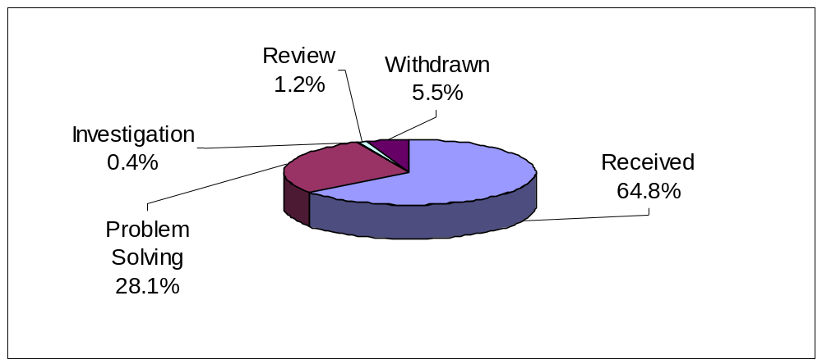

- 166 complaints were not registered.
- 72 complaints were considered at the Problem Solving Stage.
- 1 complaint was considered at investigation Stage.
- 3 complaints reached the review stage.

Outcomes of Complaints closed in the period

Stage 1 Outcomes
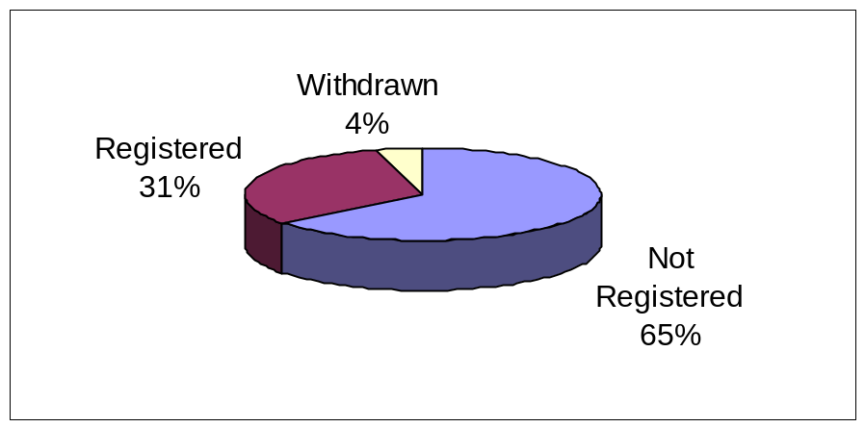

- Of ongoing and completed complaints during the period, 76 (31%) were registered, 156 (69%) were not registered, and 10 (4%) were withdrawn.

Problem-solving (Stage 2) Outcomes
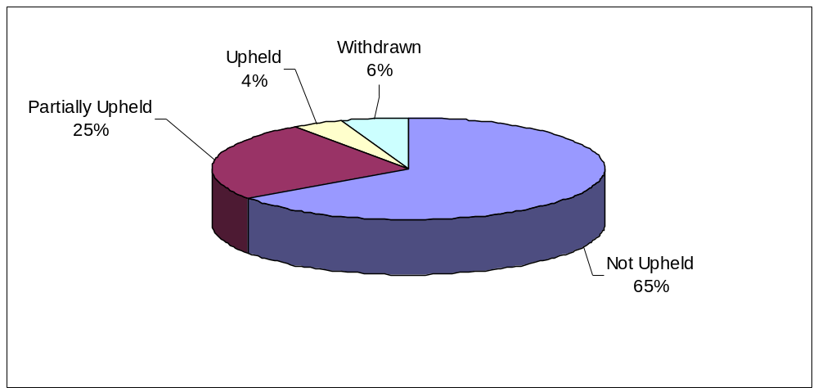

- Of 72 complaints completed at the Problem Solving stage, 47 (65%) were Not Upheld, 18 (25%) were Partially Upheld, and 3 (4%) were Upheld. 4 (6%) were withdrawn.

Investigation (Stage 3) Outcomes

- Only 1 complaint has been completed at stage 3 investigation level during the period. The outcome of this complaint was partially upheld.

- Currently, one complaint is ongoing at stage 3 investigation level.

Review (Stage 4) Outcomes

Figure 4 shows Review cases completed in the period.

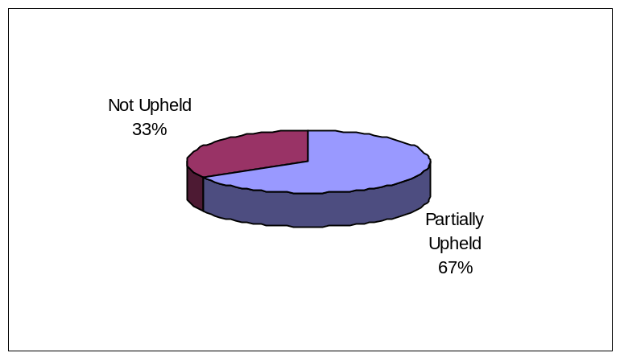

Of 3 Reviews undertaken:

- 2 complaints were partially upheld (67%)

- 1 complaint was not upheld (33%)

- Currently, there are no stage 4 reviews ongoing

Table 6: Status of Complainant

Complainant Type

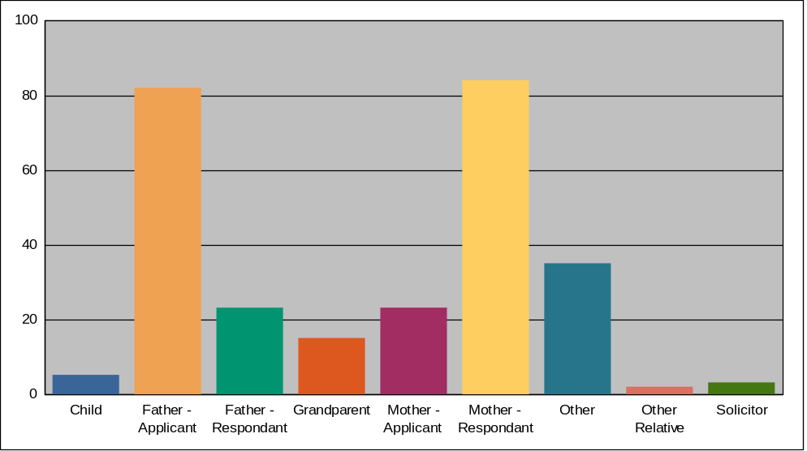

Complainant Type | Number of Complaints | % of Total
Child | 5 | 1.7%
Father - Applicant | 82 | 27.6%
Father - Respondent | 23 | 7.8%
Grandparent | 15 | 5.1%
Mother – Applicant | 23 | 7.8%
Mother - Respondent | 84 | 28.4%
Other | 35 | 11.8%
Other Relative | 2 | 0.7%
Solicitor | 3 | 1.0%
Not Recorded | 24 | 8.1%
Total: | 296 | 100.0%

- 107 (36%) complaints were made by mothers and 105 (35%) by fathers;

- 15 complaints were made by grandparents (5%);

- 3 by solicitors (1%);

- Complaints by “other” is recorded as 34 (11%)

Table 7 – Party status of complainant

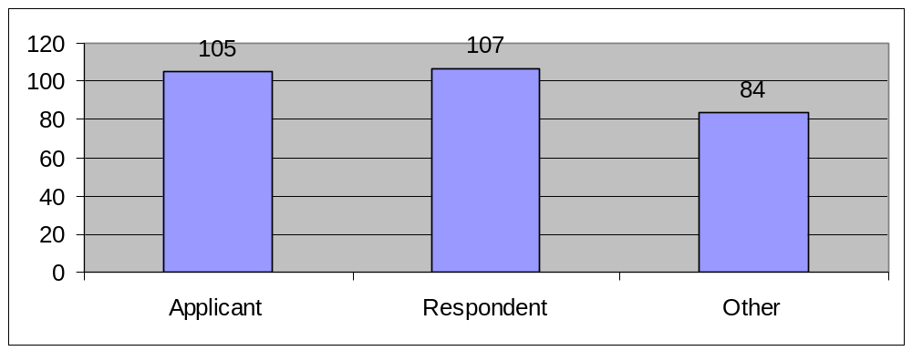

- Applicants made a total of 105 complaints (35%) with Respondents making a total of 106 complaints (36%).

- People other than the applicant or respondent made 87 complaints (29%);

Table 8 - Ethnic origins of complainants

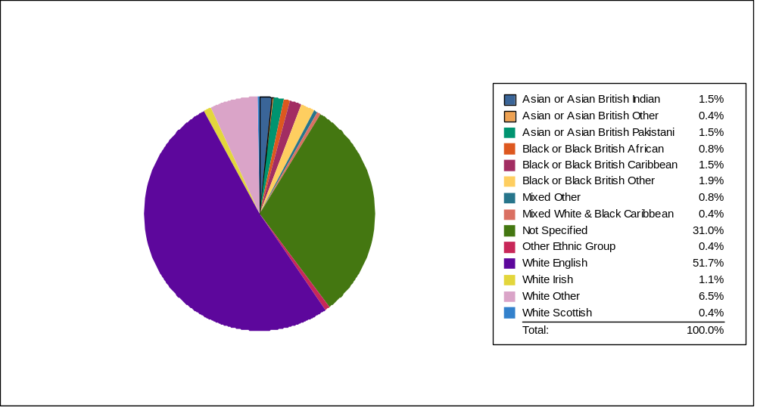

Complainant Category | Number of Complaints | % of Total
Asian or Asian British Indian | 4 | 1.5%
Asian or Asian British Other | 1 | 0.4%
Asian or Asian British Pakistani | 4 | 1.5%
Black or Black British African | 2 | 0.8%
Black or Black British Caribbean | 4 | 1.5%
Black or Black British Other | 5 | 1.9%
Mixed Other | 2 | 0.8%
Mixed White & Black Caribbean | 1 | 0.4%
Not Specified | 81 | 31.0%
Other Ethnic Group | 1 | 0.4%
White English | 135 | 51.7%
White Irish | 3 | 1.1%
White Other | 17 | 6.5%
White Scottish | 1 | 0.4%
Total: | 261* | 100.0%

*The total figure of the above chart differs from all other charts in this report, as we do not collect diversity information on complaints received from organisations.

The ethnic origin of the majority of complainants was recorded as White English (51.7%).

Ethnicity not specified was recorded as 54% at the same period last year, against 31% this year. This requires further examination as there are a number of reasons why ethnicity may not have been recorded including service users refusal, non case participants, and the type of case the complaint relates to. As the RFL becomes linked to case information as the year progresses we will be in a better position to explain any missing ethnicity data.

Table 9 – Gender of complainants
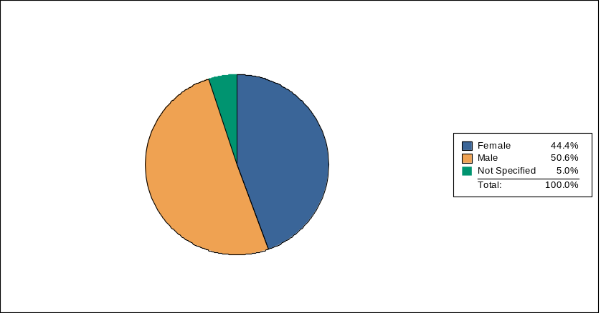

Complainant Category | Number of Complaints | % of Total
Female | 116 | 44.4%
Male | 132 | 50.6%
Not Specified | 13 | 5.0%
Total: | 261 | 100.0%

*The total figure of the above chart differs from all other charts in this report, as we do not collect diversity information on complaints received from organisations.

Table 9

shows 132 complaints (50.6%) were made by males and 116 (44.4%) were made by females.

Children’s Complaints

Simon Bartrum

Since 1st April 2006 a total of 5 new complaints were received from children.

Of the 5 complaints received:
- 1 has been completed at stage 2 (South West region)
- 1 was referred to NYAS (Greater London region)
- 1 was withdrawn (East Midlands region)
- 1 is ongoing at stage 1 (North West region)
- 1 is ongoing at stage 2 (East Midlands region)

An advocate was offered in each case and assigned to the complaints in 4 cases. Unusually one of these was appointed as an advocate working for a child living in another country, New Zealand.

4 of the complaints received by children were recorded as being ‘not acting in the interest of the child’ and 1 related to ‘process issues’.

Ethnicity in Children’s complaints

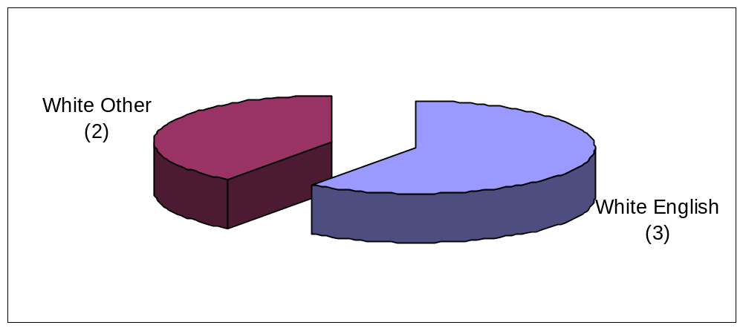

Gender data in Children’s complaints

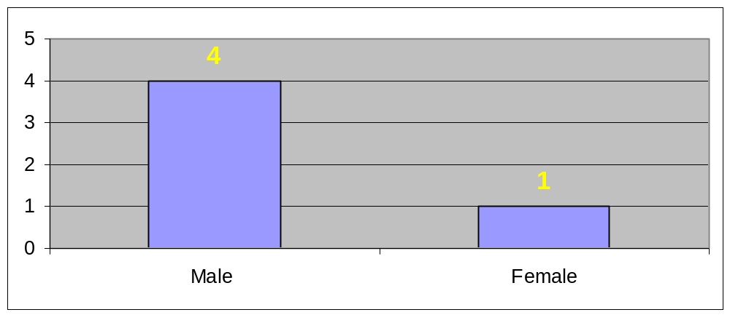

Table 10 - Comments and Compliments

 | Comments | Compliments | Total
Eastern | 2 | 16 | 18
East Midlands | 7 | 3 | 10
Greater London | 7 | 4 | 11
North East | 3 | 1 | 4
North West | 18 | 8 | 26
South East | 14 | 12 | 26
South West | 4 | 17 | 21
Southern | 4 | 5 | 9
West Midlands | 17 | 8 | 25
Yorkshire | 7 | 9 | 16
TOTAL | 83 | 83 | 166

Table 11 – MP letters and PHSO Enquiries

 | MP Letters | PHSO Enquiries
Eastern | - | 1
East Midlands | 5 | 3
Greater London | 1 | -
North East | 1 | 3
North West | - | 4
South East | 3 | 1
South West | 4 | 1
Southern | - | 1
West Midlands | 1 | 2
Yorkshire | 2 | 1
Total | 17 | 17

Of the above, responses to MP letters were provided by the following offices:

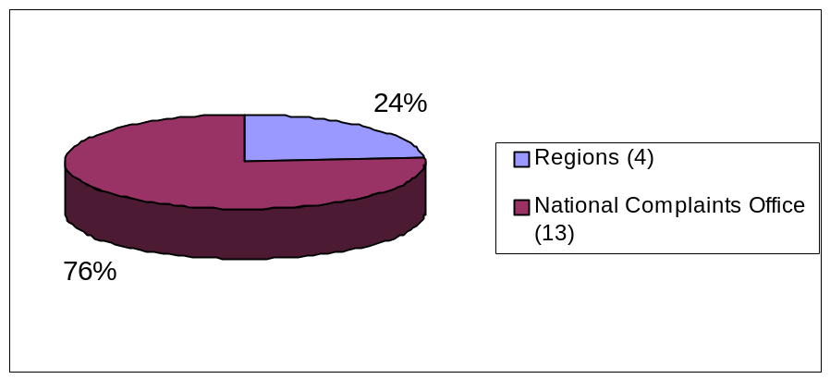

Enquiries made by the Parliamentary and Health Service Ombudsman (PHSO) in response to public requests.

During the period 1st April and 30th September 2006 the PHSO received 17 enquiries from members of the public submitted via their MPs about CAFCASS administration. Of these, 3 were formally investigated by the Ombudsman, and 1 was found to be partially justified as a complaint of maladministration.

Of the 14 that were not investigated by the Ombudsman, 12 were not upheld on the basis that there was no evidence provided to support the allegations of maladministration that had been made.

The remaining 2 referrals were not examined further as they were found to be outside the jurisdiction of the Ombudsman.

Of those 3 the PHSO decided to investigate, 2 related to incidents that occurred in 2005 and 1 related to an issue that occurred in 2004.

Of the other 14 cases the Ombudsman considered but did not investigate further:
- 11 related to incidents and events in 2005/06
- 1 related to an incident or event that occurred in 2003
- 1 related to an incident or event that occurred in 2006/07.

